Project Design Phase
Solution Architecture

Date | 2-01-2026
Team ID
Project Name | SuperBuy – E-Commerce Platform
Maximum Marks | 4 Marks

Solution Architecture
The solution architecture for SuperBuy is designed to deliver a secure, scalable, and user-friendly e-commerce platform. The architecture ensures smooth communication between users, sellers, and administrators while maintaining efficient data handling and system performance.
The system follows a three-tier architecture, consisting of:
- Presentation Layer (Frontend)
- Application Layer (Backend / Business Logic)
- Data Layer (Database)
This structured approach ensures maintainability, scalability, and high performance across the platform.

Key Architectural Features
- Seamless browsing and purchasing experience for users
- Efficient product and order management for sellers
- Secure authentication and role-based authorization
- Reliable order processing and transaction handling
- Real-time updates for orders, products, and user activity
- Scalable system architecture to support future enhancements

Architecture Components
1. Presentation Layer (Frontend)
- Developed using React.js
- Handles user interaction and UI rendering
- Communicates with backend services using RESTful APIs
- Supports responsive design for desktop, tablet, and mobile devices

2. Application Layer (Backend)
- Built using Node.js and Express.js
- Handles business logic such as authentication, cart management, orders, and reviews
- Implements role-based access control (User, Seller, Admin)
- Ensures secure API communication between frontend and database

3. Data Layer (Database)
- Uses MongoDB for efficient and scalable data storage
- Stores:
  - User information
  - Product details
  - Orders and transaction data
  - Reviews and ratings
- Ensures data integrity, consistency, and scalability

Security & Authentication
- JWT-based authentication
- Encrypted password storage
- Role-based authorization for users, sellers, and admins
- Secure API access and protected routes

System Workflow Overview
- User registers or logs in to the platform
- User browses products and adds items to the cart or wishlist
- Orders are placed and securely stored in the database
- Sellers manage inventory and process orders
- Admin monitors system activity and manages users and content

Example – Solution Architecture Diagram
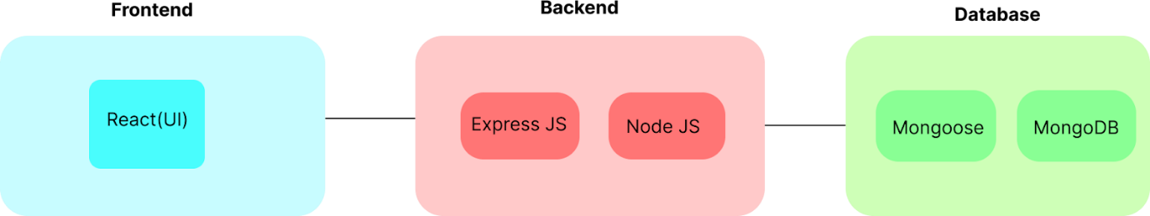
[ User / Seller / Admin ]
|
(React Frontend)
|
REST API (Express.js)
|
Business Logic Layer
|
MongoDB Database

Final Outcome
The solution architecture of SuperBuy ensures high performance, scalability, and reliability. By adopting a modular and layered design, the platform supports smooth interactions between users, sellers, and administrators while enabling future feature expansion and system growth.

